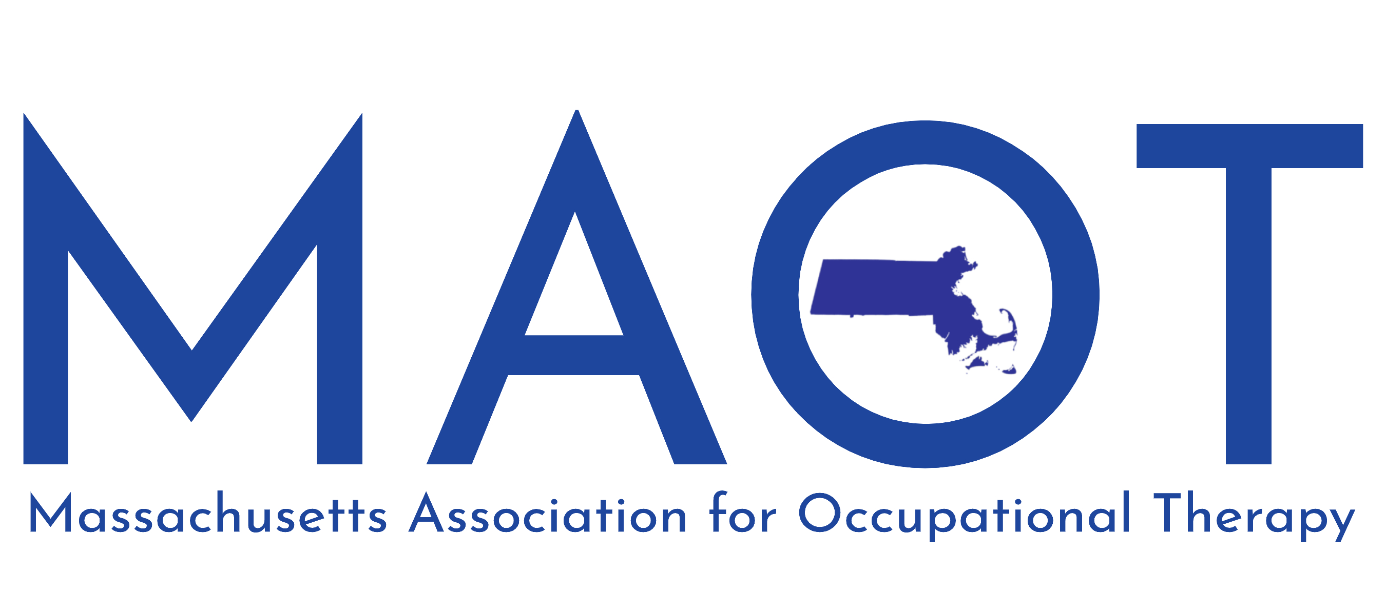
57 Madison Road
Waltham, MA 02453
Phone: 781-647-5556; E-mail: info@maot.org

CALL FOR AWARD NOMINATIONS
Nominations must be received via email or postmarked by September 30, 2021

Directions
Recipients must be nominated by a fellow occupational therapy practitioner.
Submit nominations to MAOT's Administrative Assistant, with a completed nomination form describing the candidate's credentials and reasons for nomination. Nominations will be returned to you if they do not include the required information. There is no limit to the number of nominations you may submit.
The MAOT executive board will review all nominations and the recipient will be notified prior to the Annual MAOT conference.

If you have any further questions or would like some guidance, contact the nominations Chair at MAOT.

Nomination Application: Complete the nomination process by providing the MAOT nominations' chair with the following information
Check only one to indicate which award you would like your candidate to receive.

❑ Catherine A Trombly Academia Achievement Award (Contributions to the profession in the area of Education, Research and Publications)
 Linda Savino Political Achievement Award (Contributions in the area of Political Activism)
 Herbert Hall Public Relations Award (Contributions in the area of service to the profession)
 Outstanding Practitioner of the Year
 Fieldwork Educator Award
The Linda Duncombe Memorial Award
AWARD NOMINATION APPLICATION

Candidate information

Name:

Address:

E-mail:

Fax:

Phone:

Please include a personal statement regarding the candidate you wish to nominate and what qualifies this individual for a particular award. No fewer than fifty and no more than 300 words please. Feel free to make an attachment.

Nominators information:

Name:

Address:

E-mail:

Fax:

Phone:

Please tell us how you have come to know about the nominee. Feel free to make an attachment.

